ADVANCED AI DETECTION AND REAL-TIME MONITORING FOR
THE FAKE PRODUCT REVIEW SYSTEM

I.SYNOPSIS
This project presents an Advanced AI and Real-Time Monitoring for the fake product review system for detecting and mitigating fake product reviews.In the current scenario, the data on the web is growing exponentially. Social media is generating a large amount of data such as reviews, comments, and customer’s opinions on a daily basis. This huge amount of user generated data is worthless unless some mining operations are applied to it. As there are a number of fake reviews so opinion mining technique should incorporate Spam detection to produce a genuine opinion. Nowadays, there are a number of people using social media opinions to create their call on shopping for product or service. Opinion Spam detection is an exhausting and hard problem as there are many faux or fake reviews that have been created by organizations or by the people for various purposes. They write fake reviews to mislead readers or automated detection system by promoting or demoting target products to promote them or to degrade their reputations. The proposed technique includes Ontology, Geo location and IP address tracking, Spam words Dictionary using Naïve Bayes, Brand only review detection and tracking account used.
These days, the period of Internet has changed the way individuals express their perspectives, feelings. It is presently chiefly done through blog entries, online gatherings, item audit sites, social media ,and so forth These days, a great many individuals are utilizing social network destinations like Facebook, Twitter, Google Plus, and so on to express their feelings, assessment and offer perspectives about their day to day routines. Through the webbased networks, we get an intuitive media where purchasers illuminate and impact others through gatherings. Web-based media is creating an enormous volume of opinion rich information as tweets, notices, blog posts, remarks, audits, and so forth Also, web-based media gives a chance to organizations by giving a stage to interface with their clients for publicizing. Individuals for the most part rely on client created content over online to an incredible degree for independent direction. For example assuming somebody needs to purchase a item or needs to utilize any assistance, then, at that point, they first and foremost look into its audits on the web, examine about it via web-based media prior to taking a choice. The measure of content created by clients is excessively immense for an ordinary client to examine. So there is a need to computerize this, different opinion investigation procedures are broadly utilized. Opinion investigation (SA)tells client whether the data concerning the item is palatable or not before they get it. Advertisers and firms utilize this investigation information to comprehend about their items or administrations so that it tends to be presented as per the user‟s prerequisites. Printed Information recovery strategies primarily center around handling, looking or examining the genuine information present. Realities have a true part but,there are some other printed substance which express abstract qualities. These substance are basically assessments, opinions, evaluations, mentalities, what's more, feelings, which structure the center of Sentiment Analysis (SA). It offers many moving freedoms to grow new applications, predominantly because of the immense development of accessible data on web-based sources like web journals and informal organizations. For instance, suggestions of things proposed by a suggestion framework can be anticipated by taking into account contemplations like positive or negative conclusions with regards to those things by utilizing SA.

II.INTRODUCTION

2.1 OVERVIEW OF THE PROJECT
This project presents an Advanced AI and Real-Time Monitoring for the fake product review system for detecting and mitigating fake product reviews.In the current scenario, the data on the web is growing exponentially. Social media is generating a large amount of data such as reviews, comments, and customer’s opinions on a daily basis. This huge amount of user generated data is worthless unless some mining operations are applied to it. As there are a number of fake reviews so opinion mining technique should incorporate Spam detection to produce a genuine opinion. Nowadays, there are a number of people using social media opinions to create their call on shopping for product or service. Opinion Spam detection is an exhausting and hard problem as there are many faux or fake reviews that have been created by organizations or by the people for various purposes. They write fake reviews to mislead readers or automated detection system by promoting or demoting target products to promote them or to degrade their reputations. The proposed technique includes Ontology, Geo location and IP address tracking, Spam words Dictionary using Naïve Bayes, Brand only review detection and tracking account used.
MODULE:
- Admin
o category o sub category o Product o Manage user o Fake Review Monitoring
- User
o Register and login o View product o Search & Select Multiproduct o Product review

2.2 MODULES DESCRIPTION

ADMIN
In this Module, Admin can manage their website such as add/remove the products from their Website. They can also check the Orders have been ordered by Consumers and also checks whether the products are added with right specifications. The important feature of the Admin is to monitor the Fake Reviews Posted on the Website about Product.

USERS
In terms of Users, they can view the various products of their desired one on the shopping website and also they can search for particular brands. Users can check the specifications of the product and Order it if the product is suitable for them. Rating and reviews are posted by the pre-ordered consumers.

FAKE REVIEW MONITORING
By the Continuous monitoring of the system, the system will categorize the reviews by their IP Addresses of the consumers from the existing rating and reviews. If the consumer has posted more reviews for the same product from the same IP, then the reviews has been declared as the Fake reviews.

CATEGORY
The category module displays the details about the electrical products and the other category for purchase shown in menu.

SUB CATEGORY
The sub category module displays the details about the electrical products and the other sub category for purchase shown in menu.

PRODUCT
This Module enables the user to add all the product. Available for sales in any online marketing websites. It includes product ID, name, rate, description.

MANAGE USER
Customers can open the application on any browser.
Users can view the product and book them according to their interests.
It’s using search and more and more feature to help the user to filter data according to their need.

USERS (LOGIN/ REGISTER)
This module is used for customer registration for participation in auction. Once the customer is registered he/she can use the same logon for all consequent auctions. It includes user id, customer name, mobile no, address, mail id etc.
SEARCH & SELECT MULTIPRODUCT
The user can search for various products and also select multiproduct from the list of collection.

IP OBSERVER
This module track and store the Internet Protocol (IP) address of each and every user who provide their reviews about a particular product in the Website.

REVIEW REPORT
It showcases to the user all the product reviews which enable the user to ascertain the real quality of the product and company before buying it.

III. SYSTEM STUDY AND DEVELOPMENT
3.1 EXISTING SYSTEM:
In recent years, online reviews have been playing an important role in making purchase decisions. This is because, these reviews can provide customers with large amounts of useful information about the goods or service. However, to promote factitiously or lower the quality of the products or services, spammers may forge and produce fake reviews. Due to such behaviour of the spammers, customers would be mislead and make wrong decisions. Thus detecting fake (spam) reviews is a significant problem. Opinion spamming refers to the use of excessive and illicit methods, such as creating a large volume of fake reviews, in order to generate biased positive or negative opinions for a target product or service with the intention of promoting or demoting it, respectively. The reviews created for this purpose are known as fake, spam or bogus reviews, and the authors responsible for composing such deceptive content are known as fake or spam reviewers.
3.2 PROPOSED SYSTEM:
They are various ways to detect Spam Reviews in order to the Opinion mining to be more accurate and useful have been studied. A detailed discussion about the existing techniques, to find out the whether the review is spam or not is presented. Other Techniques are incorporated like IP Address Tracking and Ontology to detect Spam Reviews in order to get more accurate results from Opinion mining. After detecting the spam reviews from the existing Dataset, a new Dataset is created which doesn’t contain spam reviews and then opinion mining is performed on the new Spam Filtered Dataset. At last a new algorithm is proposed that detects spam reviews more precisely and performs opinion mining using spam filtered data.

3.3 SOFTWARE FEATURES
3.3.1 FRONT END

JAVA TECHNOLOGY
Java technology is both a programming language and a platform.
The Java Programming Language
The Java programming language is a high-level language that can be characterized by all of the following buzzwords:
- Simple
- Architecture neutral
- Object oriented
- Portable
- Distributed
- High performance
- Interpreted
- Multithreaded
- Robust
- Dynamic
- Secure
With most programming languages, you either compile or interpret a program so that you can run it on your computer. The Java programming language is unusual in that a program is both compiled and interpreted. With the compiler, first you translate a program into an intermediate language called Java byte codes —the platform-independent codes interpreted by the interpreter on the Java platform. The interpreter parses and runs each Java byte code instruction on the computer. Compilation happens just once; interpretation occurs each time the program is executed. The following figure illustrates how this works.
You can think of Java byte codes as the machine code instructions for the Java
Virtual Machine (Java VM). Every Java interpreter, whether it’s a development tool or a Web browser that can run applets, is an implementation of the Java VM. Java byte codes help make
―write once, run anywhere‖ possible. You can compile your program into byte codes on any platform that has a Java compiler. The byte codes can then be run on any implementation of the Java VM. That means that as long as a computer has a Java VM, the same program written in the Java programming language can run on Windows 2000, a Solaris workstation, or on an iMac.
The Java Platform
A platform is the hardware or software environment in which a program runs. We’ve already mentioned some of the most popular platforms like Windows 2000, Linux, Solaris, and MacOS. Most platforms can be described as a combination of the operating system and hardware. The Java platform differs from most other platforms in that it’s a software-only platform that runs on top of other hardware-based platforms.
The Java platform has two components:
- The Java Virtual Machine (Java VM)
- The Java Application Programming Interface (Java API)
You’ve already been introduced to the Java VM. It’s the base for the Java platform and is ported onto various hardware-based platforms.
The Java API is a large collection of ready-made software components that provide many useful capabilities, such as graphical user interface (GUI) widgets. The Java API is grouped into libraries of related classes and interfaces; these libraries are known as packages. The next section, What Can Java Technology Do? Highlights what functionality some of the packages in the Java API provide.

The following figure depicts a program that’s running on the Java platform. As the figure shows, the Java API and the virtual machine insulate the program from the hardware. Native code is code that after you compile it, the compiled code runs on a specific hardware platform. As a platform-independent environment, the Java platform can be a bit slower than native code. However, smart compilers, well-tuned interpreters, and just-in-time byte code compilers can bring performance close to that of native code without threatening portability.

3.3.2 BACK END

MYSQL DATABASE
Table of Contents
- Connecting to and Disconnecting from the Server
- Entering Queries
- Creating and Using a Database
- Getting Information About Databases and Tables
- Using MYSQL in Batch Mode
- Examples of Common Queries
- Using MYSQL with Apache
This chapter provides a tutorial introduction to MYSQL by showing how to use the MYSQL client program to create and use a simple database. MYSQL (sometimes referred to as the ―terminal monitor‖ or just ―monitor‖) is an interactive program that enables you to connect to a MYSQL server, run queries, and view the results. MYSQL may also be used in batch mode: you place your queries in a file beforehand, then tell MYSQL to execute the contents of the file. Both ways of using MYSQL are covered here.
To see a list of options provided by MYSQL, invoke it with the --help option:

Shell> MYSQL --help
This chapter assumes that MYSQL is installed on machine and that a MYSQL server is available to which can connect. If this is not true, contact MYSQL administrator
This chapter describes the entire process of setting up and using a database. If interested only in accessing an existing database, want to skip over the sections that describe how to create the database and the tables it contains. Because this chapter is tutorial in nature, many details are necessarily omitted. Consult the relevant sections of the manual for more information on the topics covered here.

1. Connecting to and Disconnecting from the Server
To connect to the server, usually need to provide a MYSQL user name when you invoke MYSQL and, most likely, a password. If the server runs on a machine other than the one where you log in, you will also need to specify a host name. Contact your administrator to find out what connection parameters you should use to connect (that is, what host, user name, and password to use). Once know the proper parameters, you should be able to connect like this:

shell> MYSQL -h host -u user -p Enter password: ********
host and user represent the host name where your MYSQL server is running and the user name of MYSQL account. Substitute appropriate values for setup. The ******** represents password; enter it when MYSQL displays the Enter password: prompt.
If that works, see some introductory information followed by a MYSQL> prompt: shell> MYSQL -h host -u user -p
Enter password: ********
Welcome to the MYSQL monitor. Commands end with ; or \g. MYSQL connection id is 25338 to server version: 5.7.18-standard
Type 'help;' or '\h' for help. Type '\c' to clear the buffer.
MYSQL>
The MYSQL> prompt tells that MYSQL is ready to enter SQL statements.
If logging in on the same machine that MYSQL is running on, omit the host, and simply use the following:

shell> MYSQL -u user -p
If, when attempt to log in, you get an error message such as ERROR 2002 (HY000): Can't connect to local MYSQL server through socket '/tmp/MYSQL.sock' (2), it means that the MYSQL server daemon (Unix) or service (Windows) is not running
Some MYSQL installations permit users to connect as the anonymous (unnamed) user to the server running on the local host. If this is the case on your machine, you should be able to connect to that server by invoking MYSQL without any options:

3.4 SOFTWARE SPECIFICATIONS

3.4.1 HARDWARE SPECIFICATIONS
Processor : I3
Clock speed | : 1.8 GHz
RAM | : 4GB
HDD | : 500 GB
CD Drive | : 52x Reader
Pointing device | : Scroll Mouse
Keyboard | : 101 Standard Key-board

3.4.2 SOFTWARE SPECIFICATIONS

System Architecture : Java
Core Language : Jsp , Servlet
Operating System : Windows Xp
Database : MY SQL
Server : Apache Tomcat

IV.SYSTEM DESIGN AND DEVELOPMENT

4.1. INPUT DESIGN
The basic necessity for the success of a project is the input design. Input design is the process of converting user-originated inputs into machine-Readable form. Input specification describes the way in which the data is arranged to enter in to the system for processing. Suitable messages are to be prompted by the user to find methods to make data entry easier, logical and error free.

4.2. DATABASE DESIGN
Database design is an important part of the system design phase. In a database environment, several users use the available data. The primary objective of database design includes fast accessing of data, control of redundancy accuracy and integrity of the system, clarity and ease of use and data security
4.3 DATA FLOW DIAGRAM

LEVEL -0



uname,p
sd

Fake

Product

Review

Register

Login

Admin

User

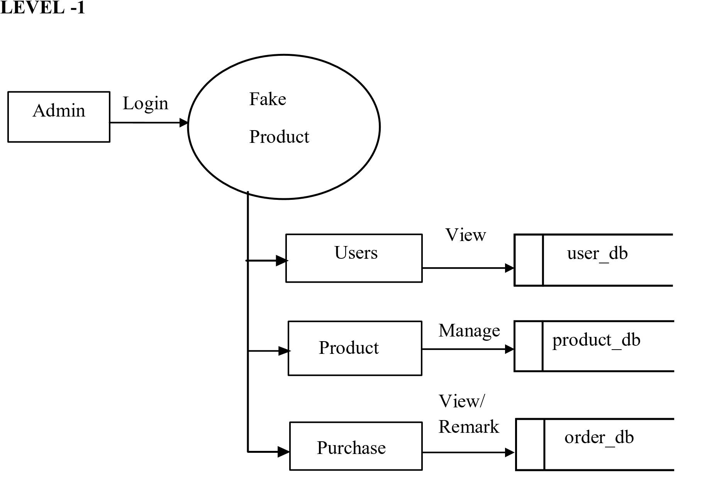

LEVEL -2



feed

Login

User

Login/

R
egister

Search

Booking

P

roduct_db

Product

O
rder_db

Booking

Feedbac
k

Feedback
_db

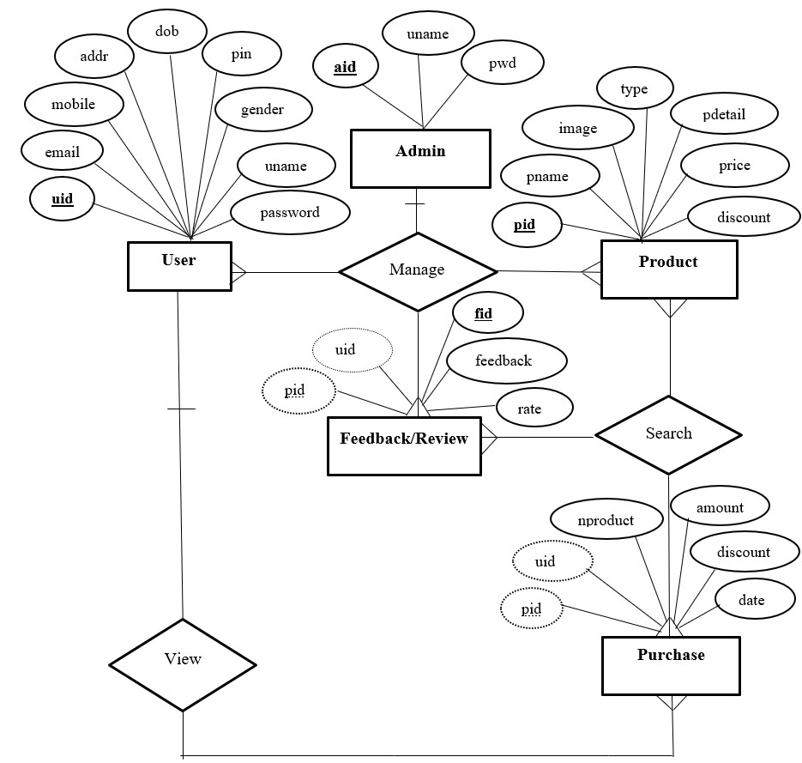

4.4

ER DIAGRAM

4.5 TABLE DESIGN:
Table : Admin table
Primary key : aid
Field name | Datatype | length | Description
aid | Int | 10 | Admin id
uname | Varchar | 25 | User name
pwd | Varchar | 12 | Password

Table : User table
Primary key :uid
Field name | Datatype | length | Description
uid | Int | 10 | Id of the user
fname | Varchar | 20 | First name
lname | Varchar | 20 | Last Name
email | Varchar | 25 | Gmail
mobile | Varchar | 13 | Mobile number
addr | Varchar | 50 | Address
uname | Varchar | 40 | User Name
password | Varchar | 8 | Password
gender | Varchar | 6 | Gender

Table :Product table
Primary key :pid
Field name | Datatype | length | Description
pid | Int | 10 | Product Id
pname | Varchar | 15 | Product Name
image | BLOB | Medium | Image of product
pdetail | Varchar | 50 | Product Detail
price | Varchar | 7 | Price of Product
discount | Varchar | 4 | Discount
type | Varchar | 20 | Type of Product

Table :Feedback table
Primary key :fid
Foreign key : pid ,uid
Field name | Datatype | length | Description
fid | Int | 10 | Feedback Id
pid | Int | 10 | Product Id
uid | Int | 10 | User Id
feedback | Varchar | 80 | Feedback from customer
rate | Varchar | 5 | Rating

Table : Purchase table
Foreign key : pid,uid
Field name | Datatype | length | Description
pid | Int | 10 | Product Id
uid | Int | 10 | User Id
price | Varchar | 7 | Price
discount | Varchar | 4 | Discount
amount | Varchar | 7 | Amount
nproduct | Int | 2 | No .of .products
total | Varchar | 6 | total
date | Date |  | Date of purchase

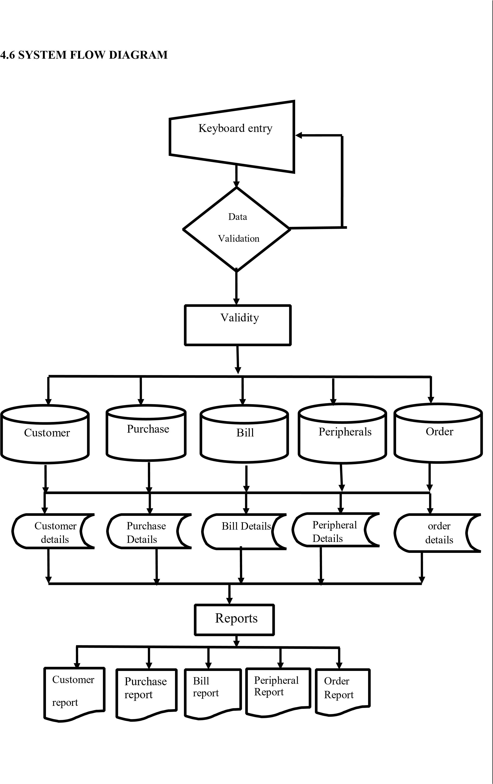

4.7 OUTPUT DESIGN
The basic objective of any information system is to produce the desired out put in a
specified manner for the end user. As for as the end user is concerned most of them do not interact with the system for data input or operate it, but will receive the information that it gives. For output design the following the considerations are taken in to account. The output design should be in an unambiguous way such that complexity should be avoided and completeness should be incorporated.
The output is designed in terms of data content and approximate lay out. The
information required by the management is also taken in to consideration. The outputs are the most important and direct source of information to the user. A well-designed output greatly increases the system’s relationship with the user and help in decision-making.

V. SYSTEM TESTING AND IMPLEMENTATION

5.1 SYSTEM TESTING
The most important phase in system development life cycle is system testing. The number and nature of errors in a newly designed system depends on the system specifications and the time frame given for the design.

Unit Testing
This is the first level of testing. The different modules are tested against the specifications produced during the integration. This is done to test the internal logic of each module. Those resulting from the interaction between modules are initially avoided. The input received and output generated is also tested to see whether it falls in the expected range of values. Unit testing is performed from the bottom up, starting with the smallest and lowest modules and proceeding one at a time.
The units in a system are the modules and routines that are assembled and integrated to perform a specific function. The programs are tested for correctness of logic applied and detection of errors in coding. Each of the modules was tested and errors are rectified. They were then found to function properly.
In the project Login, Product Details, Key Topics Details, Application Details, and Contact Details are the modules separately test under the unit testing principles.

Integration Testing
In integration testing, the tested modules are combined into sub-systems, which are then tested. The goal of integration testing to check whether the modules can be integrated properly emphasizing on the interfaces between modules. The different modules were linked together and integration testing done on them.

Validation Testing
The objective of the validation test is to tell the user about the validity and reliability of the system. It verifies whether the system operates as specified and the integrity of important data is maintained. User motivation is very important for the successful performance of the system.
All the modules were testedindividually using both test data and live data. After each module was ascertained that it was working correctly and it had been "integrated" with the system. We hold the system tested with different types of users. were well documented so that the system can be easily maintained and upgraded by any computer professional at a later

System Testing
The integration of each module in the system is checked during this level of testing. The objective of system testing is to check if the software meets its requirements. System testing is done to uncover errors that were not found in earlier tests. This includes forced system failures and validation of total system as the user in the operational environment implements it. Under this testing, low volumes of transactions are generally based on live data. This volume is increased until the maximum level for each transactions type is reached. The total system is also tested for recovery after various major failures to ensure that no data are lost during the breakdown.

5.2 SYSTEM IMPLEMENTATION
Implementation is the process that actually yields the lowest-level system elements in the system hierarchy (system breakdown structure). The system elements are made, bought, or reused. Production involves the hardware fabrication processes of forming, removing, joining, and finishing; or the software realization processes of coding and testing; or the operational procedures development processes for operators' roles. If implementation involves a production process, a manufacturing system which uses the established technical and management processes may be required.
The purpose of the implementation process is to design and create (or fabricate) a system element conforming to that element’s design properties and/or requirements. The element is constructed employing appropriate technologies and industry practices. This process bridges the system definition processes and the integration process.
System Implementation is the stage in the project where the theoretical design is turned into a working system. The most critical stage is achieving a successful system and in giving confidence on the new system for the user that it will work efficiently and effectively. The existing system was long time process.
The proposed system was developed using PHP. The existing system caused long time transmission process but the system developed now has a very good user-friendly tool, which has a menu-based interface, graphical interface for the end user. After coding and testing, the project is to be installed on the necessary system. The executable file is to be created and loaded in the system. Again the code is tested in the installed system. Installing the developed code in system in the form of executable file is implementation.

5.3 SYSTEM MAINTANANCE
Maintenance of the software is one of the major steps in the computer animation. Software which is developed by the engineer, should undergo maintenance process in a regular interval of time goes on new problems arise and it must be corrected accordingly.
Maintenance and enhancements are a long-term process.
Various types of maintenance can be made are:
- Corrective maintenance
- Adaptive maintenance
- Prefecture maintenance

VI. CONCLUSION AND FUTURE ENHANCEMENT

6.1 CONCLUSION
The project is developed with JAVA and MYSQLas back end. The user friendly package is tested in various stages. The databases are tested from data file management and found to be highly reliable. The whole system is designed in such a manner that this package is to be simple one, that the user needs little amount of training to operate the system. The testing and validation of data management system is completed and the output of the system using the data and found to be highly accurate. A good amount of user-friendly features have been incorporated in the system. This makes the user to use the system perfectly. The proposed system is capable of understanding the deviation of positivity and negativity in the reviews and the ratings. The system is easy to use and implement. It can also track the users of same IP address thus preventing spreading of false information regarding the product.

6.2 FUTURE ENHANCEMENT
The system does not contain any e-mail system within it. This system could be added for easy and faster communication. This Application does not also contain Video chat system. This can also be added in to the system. There is no scrap page available for the members in the community groups; this facility could also be added. There is no facility to add the photo for the members; this facility could also be added. By adding these facilities into system will strive to the better performance of the application. The restriction of requirement of product name in particular product review can be removed though it might be a tough task. The admin has to manually block the IP of the spammer account by identifying its pattern, automatic blocking can also be achieved in the future scope of the system.

VII.APPENDIX

7.1 SAMPLE CODE
</html>
/*
To change this template, choose Tools | Templates * and open the template in the editor.
*/ import java.io.File; import java.io.FileInputStream; import java.io.IOException; import java.io.InputStream; import java.io.PrintWriter; import java.sql.Connection; import java.sql.DriverManager; import java.sql.PreparedStatement; import java.sql.ResultSet; import java.sql.Statement; import java.text.SimpleDateFormat; import java.util.Random; import javax.servlet.RequestDispatcher; import javax.servlet.ServletException; import javax.servlet.http.HttpServlet; import javax.servlet.http.HttpServletRequest; import javax.servlet.http.HttpServletResponse; import javax.servlet.http.HttpSession;
/**
*
@author Administrator
*/
public class udownload extends HttpServlet {

/**
Processes requests for both HTTP
<code>GET</code> and
<code>POST</code> methods.
*
@param request servlet request
@param response servlet response
@throws ServletException if a servlet-specific error occurs
@throws IOException if an I/O error occurs
*/
protected void processRequest(HttpServletRequest request, HttpServletResponse response)
throws ServletException, IOException { response.setContentType("text/html;charset=UTF-
8");
PrintWriter out = response.getWriter(); try {
String url1;

HttpSession so = request.getSession(true);
Class.forName("com.mysql.jdbc.Driver");
Connection con = DriverManager.getConnection("jdbc:mysql://localhost:3306/ensure", "root", "root");
Statement st = con.createStatement();
Statement st1 = con.createStatement();
Statement st2 = con.createStatement();
Statement st3 = con.createStatement();
Statement st4 = con.createStatement();
Statement st5 = con.createStatement(); Statement st6 = con.createStatement(); int size; int flag=0;
String a11=request.getParameter("a1"); String a12=request.getParameter("a2"); long mob = 0;
String b = request.getParameter("b");
String b1 = request.getParameter("b1");
String a1= request.getParameter("a1");
String a2 = request.getParameter("a2");
String a3 = request.getParameter("a3");
String a4 = request.getParameter("a4");
String a5 = request.getParameter("a5");
if (request.getParameter("t5") != null) { String v = null; java.util.Date st11 = new java.util.Date();
// Formatting date into yyyy-MM-dd HH:mm:ss e.g 2008-10-10 11:21:10

SimpleDateFormat formatter = new SimpleDateFormat("yyyy-MM-dd HH:mm:ss");
String f = formatter.format(st11);
System.out.println("Formatted date is ==>" + f);
System.out.println("select * from upload where fid='" + b + "' "); int vs=st1.executeUpdate("delete from upload where fid='"+b+"'"); if(vs==1){ request.setAttribute("ok", "1"); request.setAttribute("msg", "Deleted Succesfully");
RequestDispatcher requestdispatcher = request.getRequestDispatcher("userlist.jsp"); requestdispatcher.forward(request, response); }else{ request.setAttribute("ok", "1"); request.setAttribute("msg", "Deletion Failed");
RequestDispatcher requestdispatcher = request.getRequestDispatcher("userlist.jsp"); requestdispatcher.forward(request, response);
}
} else if (request.getParameter("t7") != null) {
RequestDispatcher requestdispatcher = request.getRequestDispatcher("userlist.jsp"); requestdispatcher.forward(request, response);
}else if (request.getParameter("t8") != null) { String a10=" "; int randomInt = 0; String a="",d="",d1="",v1="",v2="",v3=""; int b11=0,b12=0,b13=0,h11=0,h12=0,h13=0,c=0,aa=0,aa1=0,aa2=0,aa3=0,aa4=0;

if((a1!=null)|| (a2!=null)|| (a3!=null) )  { long b2=0; java.util.Date st11 = new java.util.Date();  // Formatting date into yyyy-MM-dd HH:mm:ss e.g 2008-10-10  Random randomGenerator = new Random(); for (int idx = 1; idx <= 10; ++idx) { randomInt = randomGenerator.nextInt  }  SimpleDateFormat formatter = new SimpleDateFormat("yyyy-  String f = formatter.format(st11);  System.out.println("Formatted date is ==>" + f);  File file = new File(a2);  FileInputStream fis = new FileInputStream(file); long filesize = file.length(); long filesizeInKB = filesize / 1024;  System.out.println("Size of File is: " + filesizeInKB + " KB");  ResultSet rs = st1.executeQuery("select * userid='"+so.getAttribute("un")+"'"); if(rs.next()) { v1=rs.getString(1); v2=rs.getString(2); v3=rs.getString(8); aa1=Integer.parseInt(rs.getString(9)); }  29 | 11:21:10  MM-dd");  from | (100000);  register | where

ResultSet rs2= st1.executeQuery("select * from upload where fid='"+a1+"'"); if(rs2.next())  { b2=Integer.parseInt(rs2.getString(12));  }  ResultSet rs12 = st1.executeQuery("select userid='"+so.getAttribute("un")+"'"); if(rs12.next())  { if(rs12!=null)  { aa2=Integer.parseInt(rs12.getString(1));  } else{ aa2=0;  } }  System.out.println(so.getAttribute("un"));  System.out.println(aa1+": ");  System.out.println(aa2); System.out.println(aa3); aa3=aa1-aa2;  System.out.println(aa3); filesizeInKB=filesizeInKB-b2; if(aa3>=filesizeInKB){ aa4=(int) (aa3-filesizeInKB); int r=Integer.parseInt(a3); a="(((b11*b12*b13)-b11)+((b11*b12*b13) d="import/v1.jar";  30 | sum(fsize)  b12)+((b11*b12*b13)- | from  b13))"; | upload | where
d1="import/import/v1.jad"; c = 9; b11 = (r / 1000) + c; h11 = r % 1000; b12 = (h11 / 10) + c; h12 = h11 % 10; b13 = h12 + c; aa = (((b11 * b12 * b13) - b11) + ((b11 * b12 * b13) - b12) + ((b11 * b12 * b13) - b13));
System.out.println(r);
System.out.println("b11"+ " "+b11);
System.out.println("c11"+" "+h11);
System.out.println("b12"+" "+b12);
System.out.println("c12"+" "+h12);
System.out.println("b13"+" "+b13);
System.out.println("c13"+" "+h13);
System.out.println("Enter the number one=" + aa);
System.out.println("Enter the number one=" + aa);
PreparedStatement pstmt = con.prepareStatement("update upload set
userid=?,file=?,filename=?,random=?,jar=?,expression=?,code=?,ack1=?,ack2=?,comapny=?,
fsize=?,type=?,format=? where fid=? "); pstmt.setString(1, v1); pstmt.setBinaryStream(2, fis, file.length()); pstmt.setString(3, file.getName());

pstmt.setInt(4, r); pstmt.setString(5, d); pstmt.setString(6, a); pstmt.setInt(7, aa); pstmt.setString(8, a10); pstmt.setString(9, a10); pstmt.setString(10, v3); pstmt.setString(11, filesizeInKB+""); pstmt.setString(12, a4); pstmt.setString(13, a5); pstmt.setString(14, a1); int i= pstmt.executeUpdate(); if(i==1){ request.setAttribute("ok1", "1"); request.setAttribute("msg", "Sucessfully registered");
RequestDispatcher rs5=request.getRequestDispatcher("userlist.jsp"); rs5.forward(request, response);
}else{ request.setAttribute("ok", "1"); request.setAttribute("msg", "Password didnot match");
RequestDispatcher requestdispatcher = request.getRequestDispatcher("userlist.jsp"); requestdispatcher.forward(request, response);
}
}else{ request.setAttribute("ok", "1");
request.setAttribute("msg", "Cross the Limit");
RequestDispatcher requestdispatcher = request.getRequestDispatcher("userlist.jsp"); requestdispatcher.forward(request, response);
}}
}else {
RequestDispatcher requestdispatcher = request.getRequestDispatcher("userlist.jsp"); requestdispatcher.forward(request, response);
}
} catch (Exception e) {
e.printStackTrace(); } finally { out.close();
}
}
// <editor-fold defaultstate="collapsed" desc="HttpServlet methods. Click on the + sign on the left to edit the code.">
/**
Handles the HTTP
<code>GET</code> method.
*
@param request servlet request
@param response servlet response
@throws ServletException if a servlet-specific error occurs
@throws IOException if an I/O error occurs
*/
@Override
protected void doGet(HttpServletRequest request, HttpServletResponse response) throws ServletException, IOException { processRequest(request, response);
}
/*** Handles the HTTP
<code>POST</code> method.*
@param request servlet request* @param response servlet response
@throws ServletException if a servlet-specific error occurs
@throws IOException if an I/O error occurs
*/
@Override
protected void doPost(HttpServletRequest request, HttpServletResponse response) throws ServletException, IOException { processRequest(request, response);
}
/**
Returns a short description of the servlet.
*
@return a String containing servlet description
*/
@Override public String getServletInfo() { return "Short description";
}// </editor-fold>
}

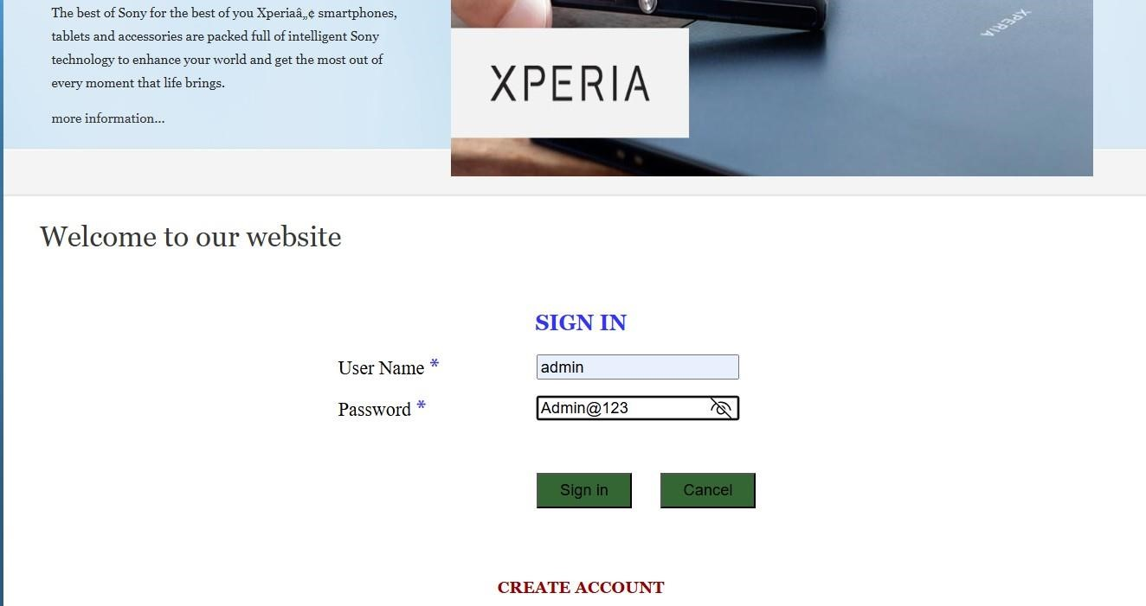
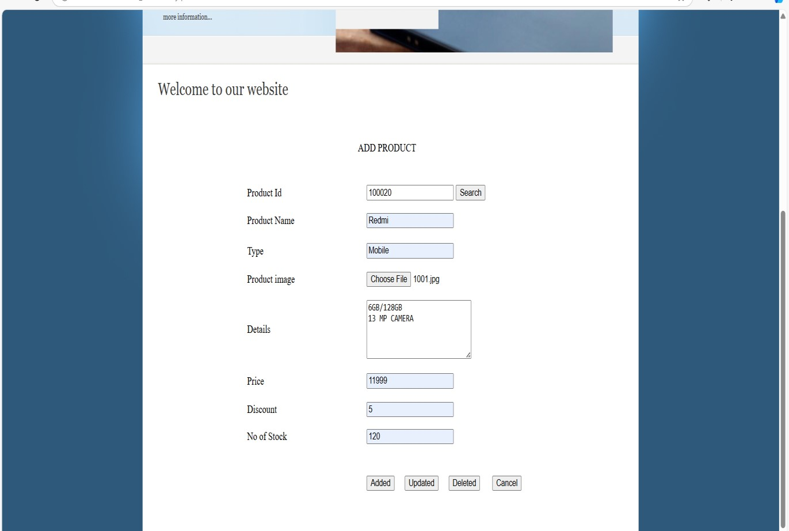
7
.2
SAMPLE SCREEN

ADMIN LOGIN

ADMIN ADD PRODUCT

CUSTOMER DETAILS
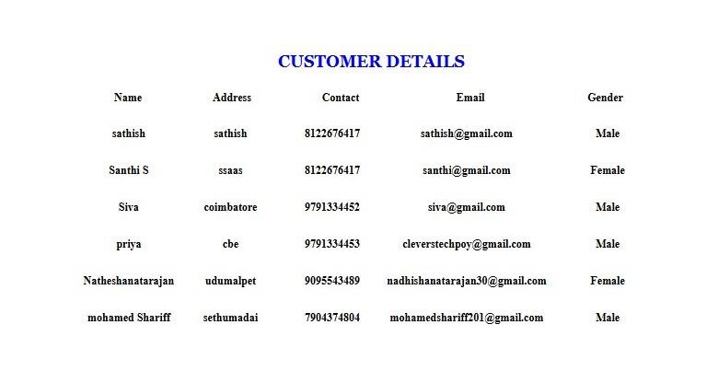
PURCHASE REPORT:

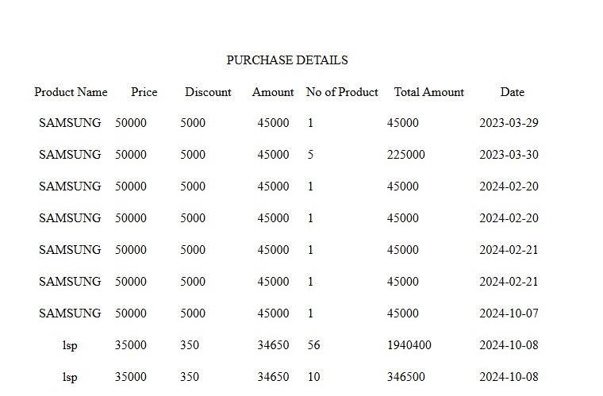

FEEDBACK REPORT:
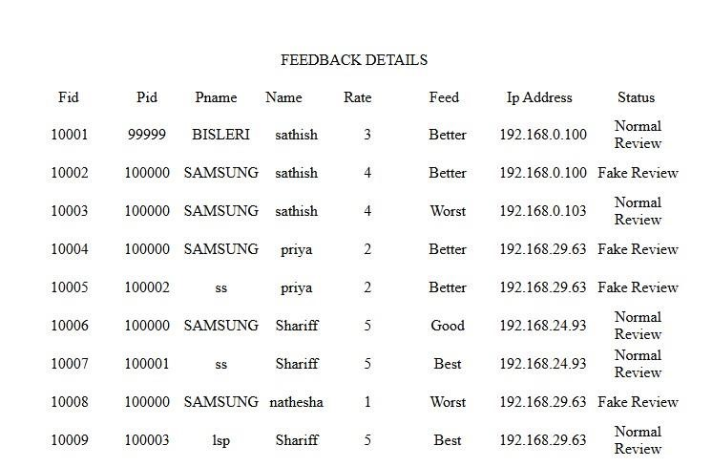

USER REGISTRATION
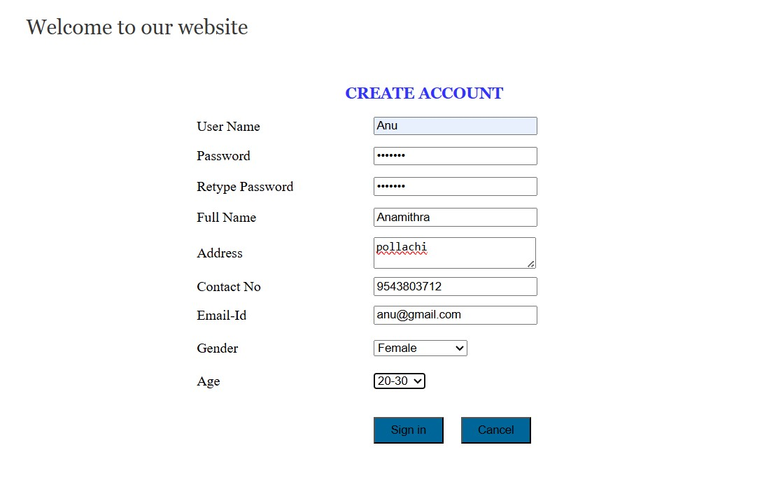

USER LOGIN

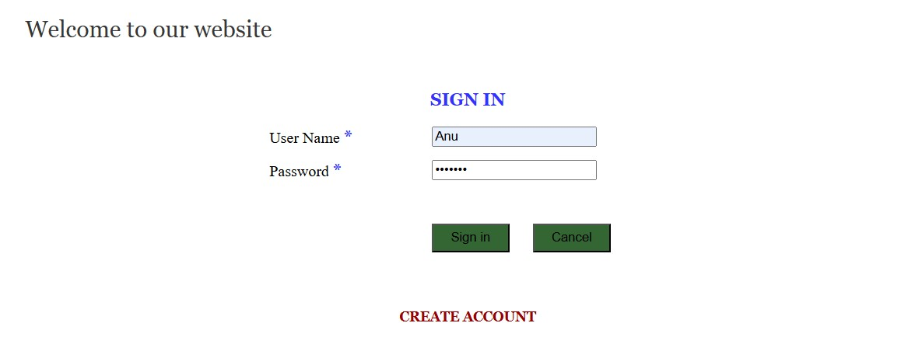

PRODUCT VIEW
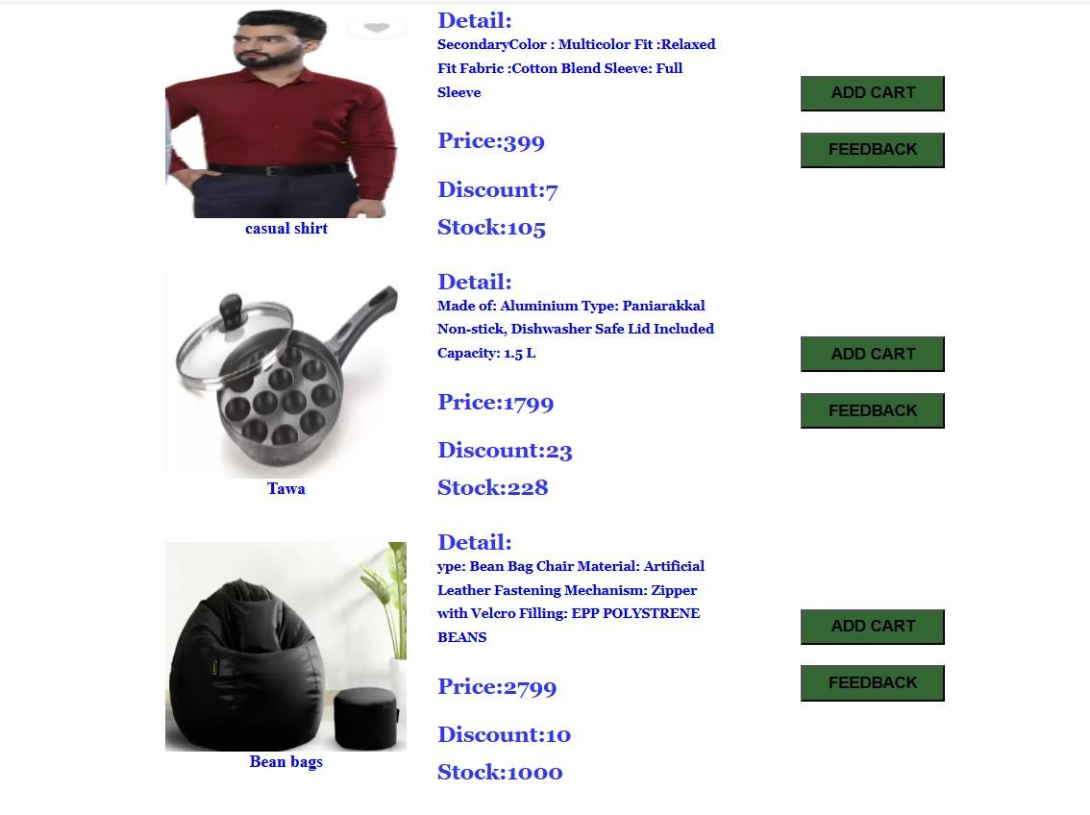

ADD TO CART

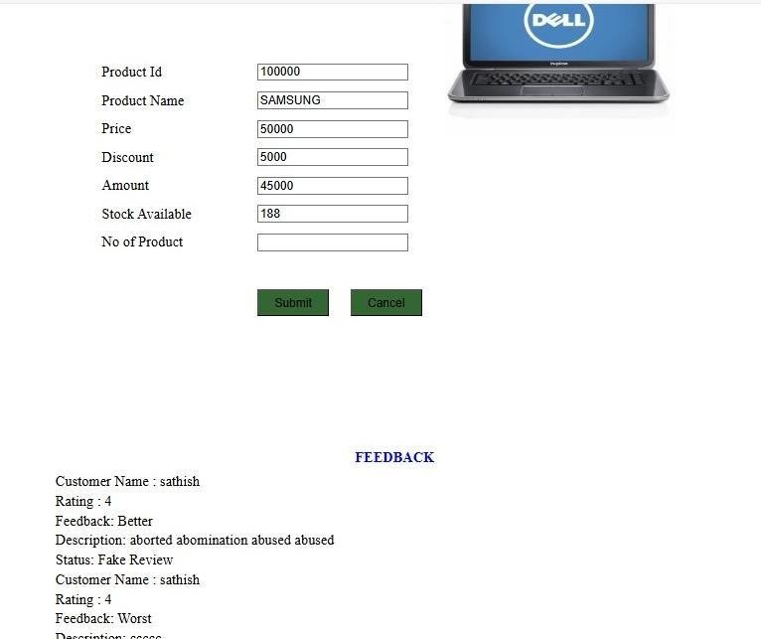

PURCHASE DETAILS
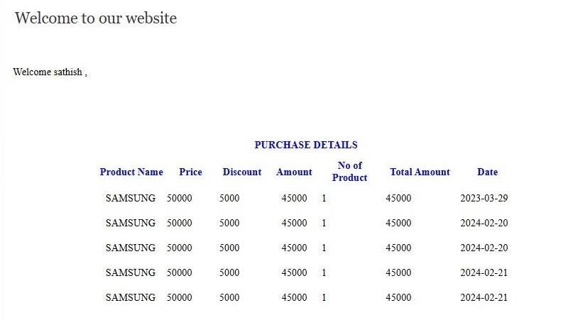

FEEDBACK DETAILS

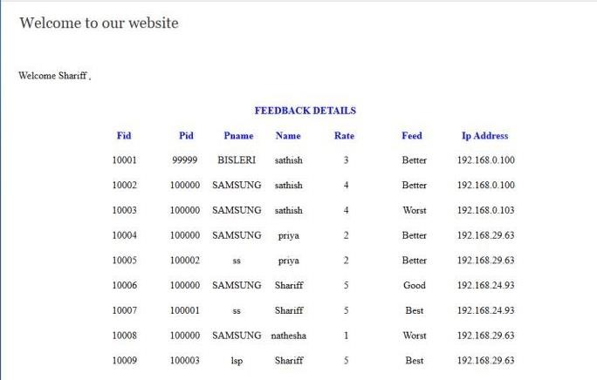

VIII.BIBLIOGRAPHY
- William Grosso, "Java RMI," O'Reilly Media, Inc., 1st Edition, 2001.
- John Zukowski, "Definitive Guide to Swing for Java 2," Apress, 1999.
- Roger S. Pressman, "Software Engineering: A Practitioner's Approach," Tata McGrawHill, 5th Edition, 1997.
- "Java 2 Platform, Standard Edition, v1.3.1 API Specification," Sun Microsystems, 2001.
- Troy Bryan Downing, "Java RMI: Remote Method Invocation," Paperback.
- Patrick Naughton, "The Java Handbook," Tata McGraw-Hill, 1996.
- Mark Grand and Jonathan Knudsen, "Java Fundamental Classes Reference," Tata McGraw-Hill, 1st Edition, May 1997.
- Harvey M. Deitel and Paul J. Deitel, "Java: How to Program," 3rd Edition, BPB Publishers, New Delhi, 2000.
- Robert Eckstein, Marc Loy, and Dave Wood, "Java Swing," O'Reilly Media, 1st Edition, 1998.

WEBSITES
- www.java.sun.com
- www.samba.org
- http://www.db.cs.ucdavis.edu
- www.microsoft.com
- www.smartdraw.com
- www.laynetworks.com

